**ADBMS Practical**

Practical 4: Operators in mongoDB

**1.Impoting the dataset and reading it.**



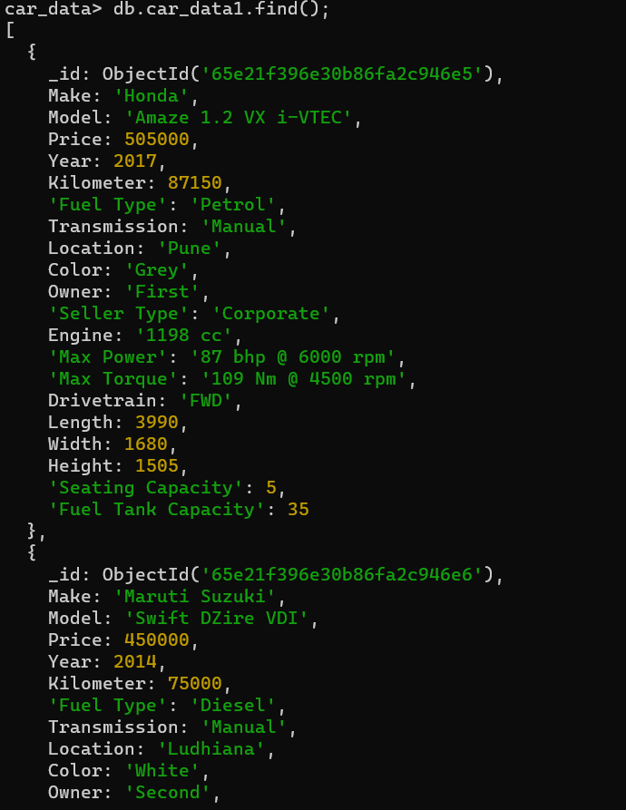

**2.Retrieving records of cars with kilometers greater than 75000**

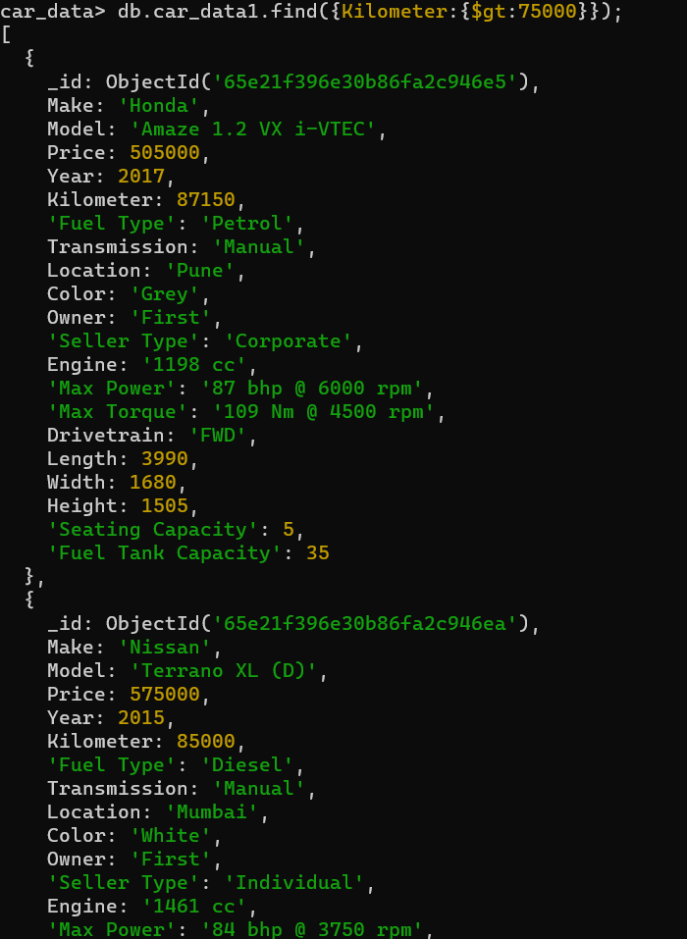

**3. Retrieving records of cars having height greater than 1650**

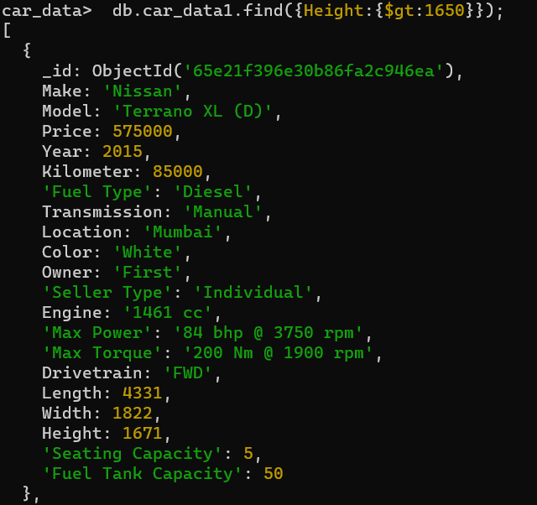

**4. Retrieving records of cars with price between 2 to 3 lakh**

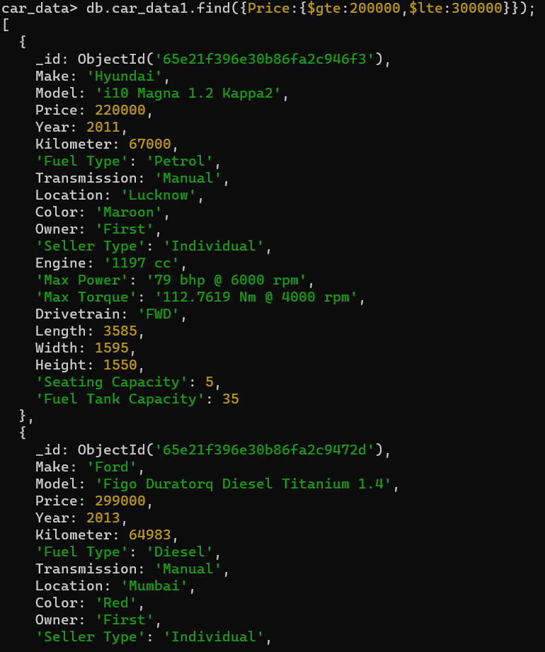

**5.Retrieving records of car of brand Toyota of color grey and first owner**

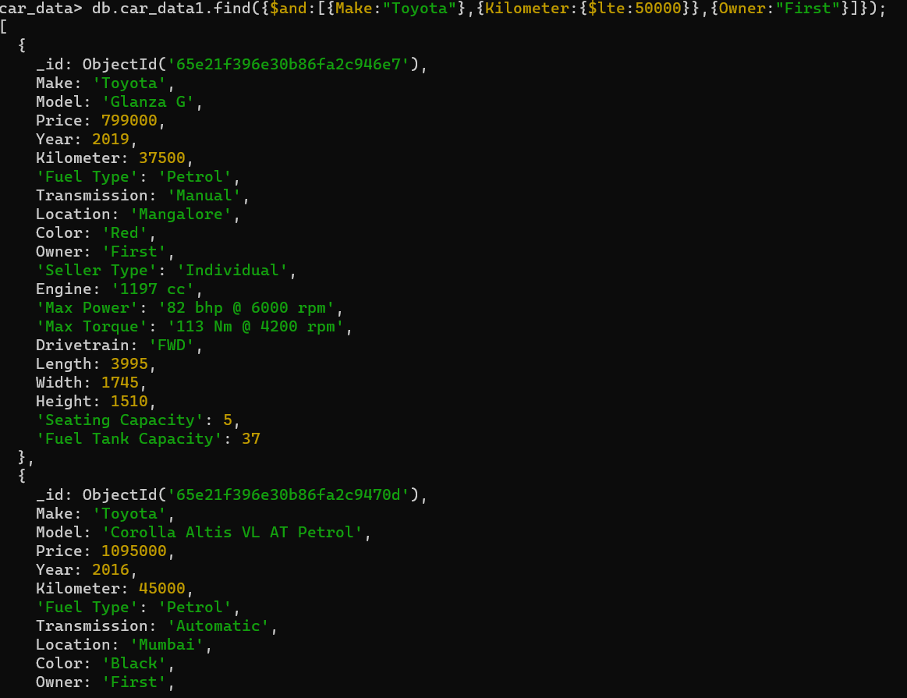

**6.Retrieving records of cars innova or cars having length greater than 4500**

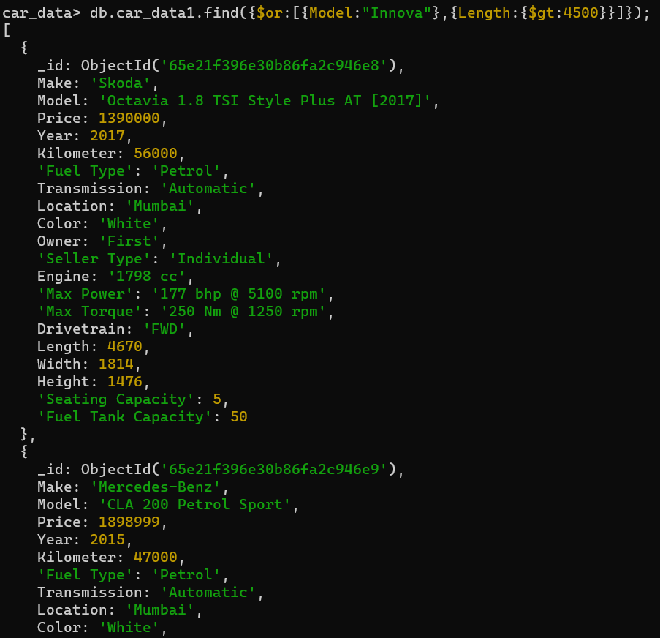

**7.Retrieving records of cars which are neither first owner nor having having kms less than 40000**

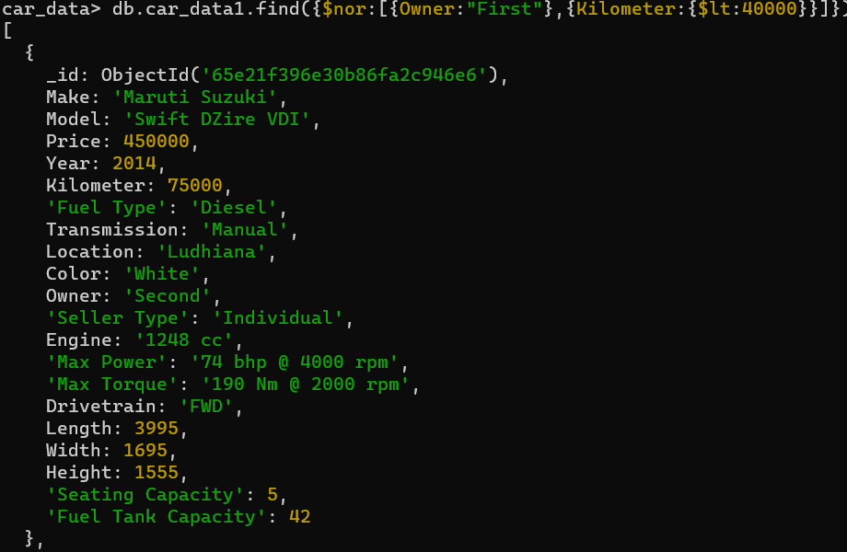

**8.** **To check the existence of a field and return its count in the dataset. Also check for null values in the existing field**

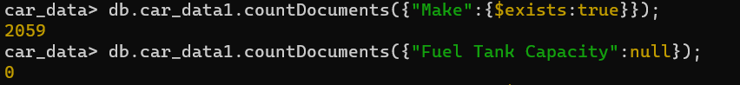

**9.Calculating minimum and maximum price.**



**10.** **Finding all records of the cheapest and costliest car.**

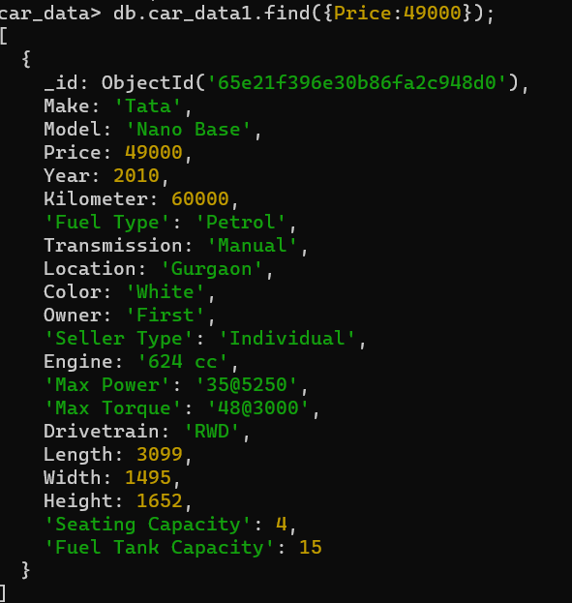

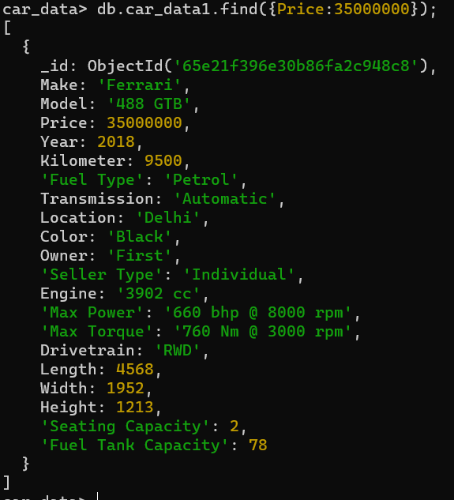

**11.** **Retrieving all records of cars not having seating capacity 5**

